**TEAM ID:** PNT2022TMID52731

**PROJECT NAME:** DemandEst - AI powered Food Demand Forecaster

**TEAM LEADER**

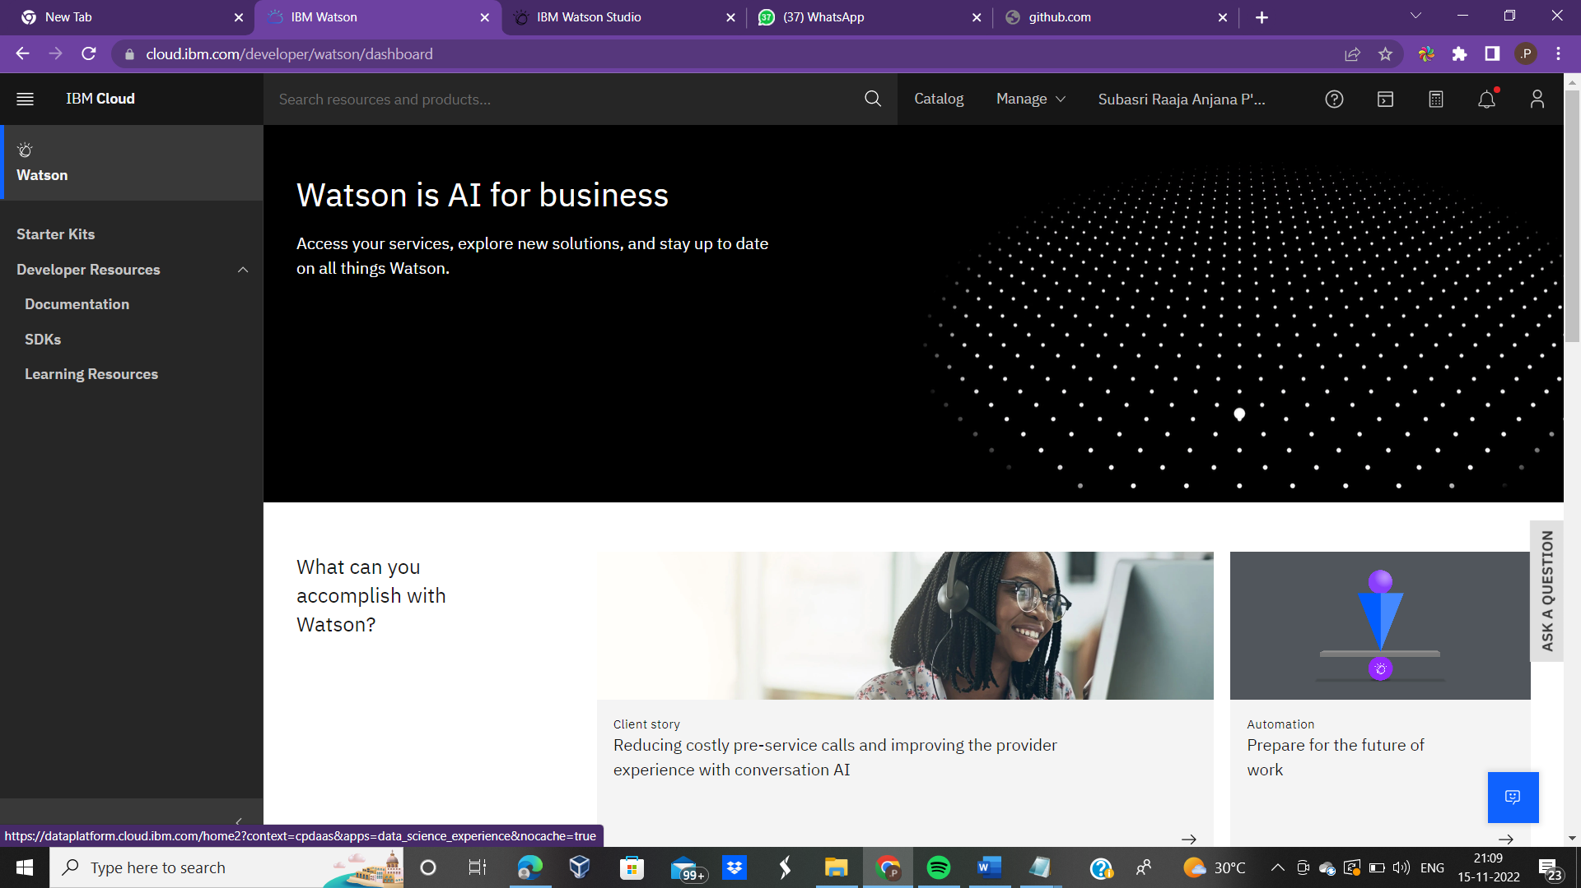

**TEAM MEMBER 1**

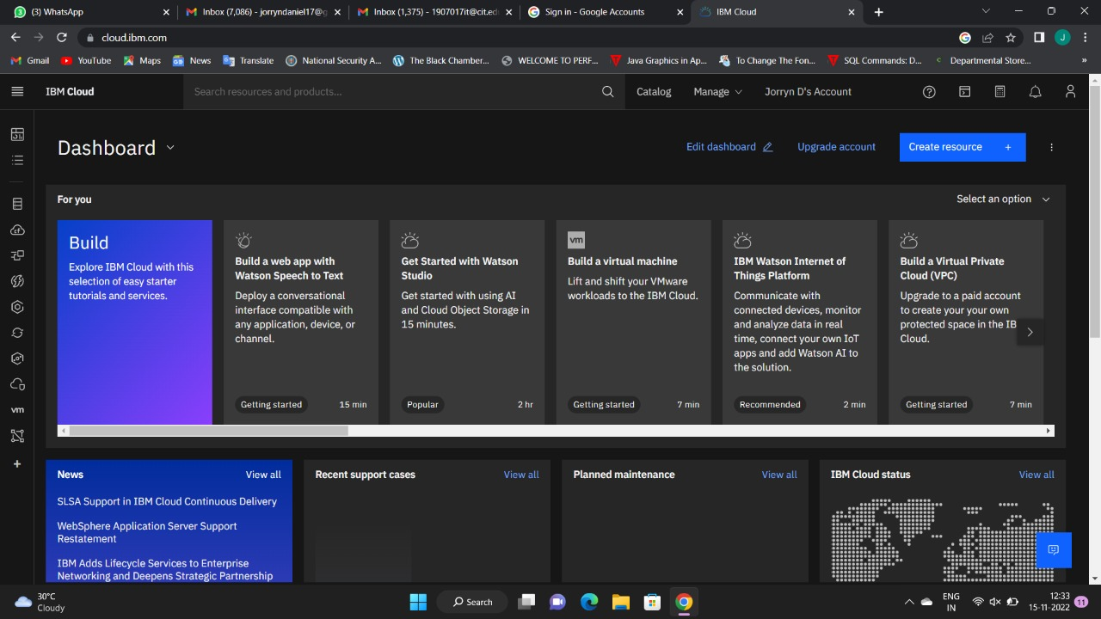

**TEAM MEMBER 2**

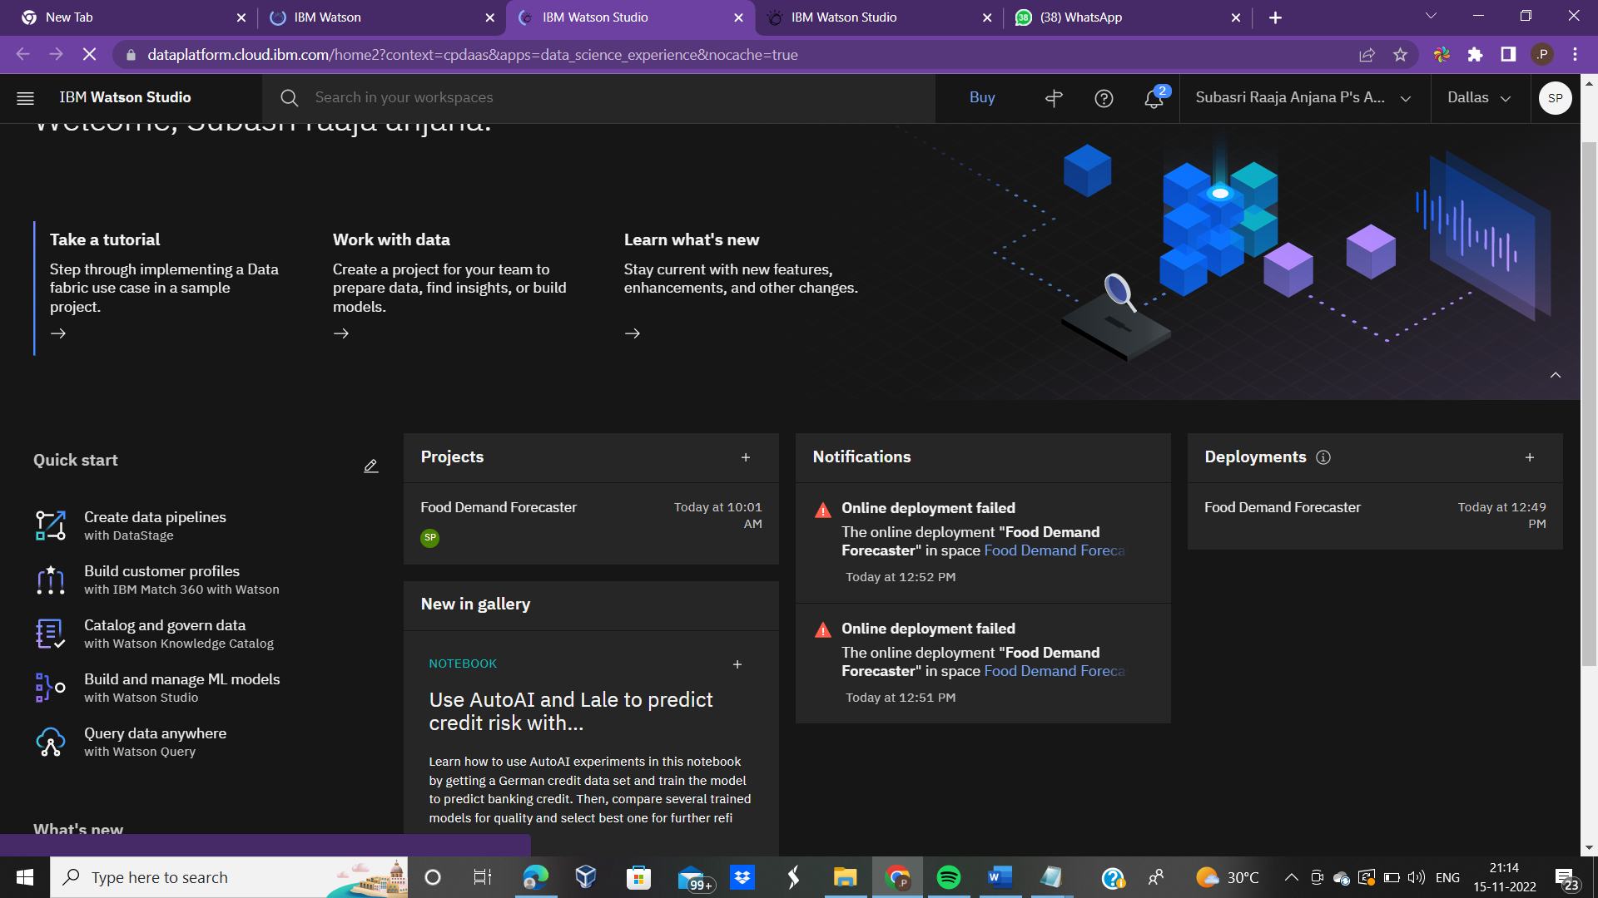

**TEAM MEMBER 3**

